**MEENAKSHI SUNDARARAJAN **

**ENGINEERING COLLEGE**

**Kodambakkam , Chennai-600024**

**NM1009 –GENERATIVE AI FOR ENGINEERING**

**DEPARTMENT OF COMPUTER SCIENCE ENGINEERING**

**TOPIC:CREDITCARD FRAUD DETECTION**

**FACULTY EVALUATOR : REVATHI**

**INDUSTRY MENTOR :**

**Project submitted by:**

N.SARAN(311521104050)

***Project report format***

**1. ABSTRACT**

**2. INTRODUCTION**

2.1Project Overview

2.2Purpose

**3. IDEATION AND PROPOSED SOLUTION** 3.1Problem statement definition

3.2Ideation and Brainstorming

3.3Proposed Solution

**4. REQUIREMENTS ANALYSIS**

4.1Functional Requirements

4.2Non-Functional Requirements

**5. PROJECT DESIGN**

5.1Briefing

5.2Solution and Technical Architecture

5.3User Stories

**6. SOLUTIONS**

6.1Development Part I

6.2Development Part II

**7. RESULTS**

7.1 Performance Metrics

**8. ADVANTAGES AND DISADVANTAGES 9. CONCLUSION**

**10. FUTURE SCOPE**

SOURCE CODE

**1. ABSTRACT**

In recent years, the proliferation of digital transactions has led to an unprecedented rise in fraudulent activities, posing significant challenges for traditional fraud detection systems. As adversaries become increasingly sophisticated, there is a growing need for innovative approaches to combat fraud effectively. Generative Artificial Intelligence (AI) has emerged as a promising tool in this regard, offering novel techniques to augment fraud detection systems.

This paper presents an overview of utilizing generative AI for fraud detection. We explore how generative models, such as Generative Adversarial Networks (GANs) and Variational Autoencoders (VAEs), can be leveraged to identify anomalous patterns indicative of fraudulent behavior. Unlike traditional rule-based systems, generative AI can learn the underlying data distribution and detect deviations from normal behavior, enabling more robust and adaptive fraud detection.

Furthermore, we discuss the challenges and opportunities associated with integrating generative AI into existing fraud detection frameworks. These include issues related to data privacy, model interpretability, and adversarial attacks. We also examine potential strategies to address these challenges, such as differential privacy techniques and adversarial training.

Through a comprehensive review of recent literature and case studies, we highlight the effectiveness of generative AI in detecting various types of fraud, including financial fraud, identity theft, and cybersecurity breaches. We also discuss practical considerations for deploying generative AI-based fraud detection systems in real-world settings, including scalability, computational resources, and regulatory compliance.

In conclusion, this paper underscores the transformative potential of generative AI for enhancing fraud detection capabilities. By harnessing the power of advanced machine learning techniques, organizations can stay one step ahead of fraudsters and safeguard their assets in an increasingly digital world.

**2. INTRODUCTION**

As digital transactions surge, so do fraudulent activities, challenging traditional detection methods. Generative Artificial Intelligence (AI) offers a promising solution. By understanding data distributions, generative AI models like Generative Adversarial Networks (GANs) and Variational Autoencoders (VAEs) excel at spotting anomalies, crucial for fraud detection.

This paper explores generative AI's potential in fraud detection across finance, e-commerce, and cybersecurity. It delves into its advantages over traditional methods and the hurdles it faces, including privacy concerns and interpretability issues. Through case studies, it showcases generative AI's effectiveness and its role in bolstering fraud prevention strategies.

**2.1 PROJECT OVERVIEW:**

The objective of this project is to develop an advanced fraud detection system using generative artificial intelligence (AI) techniques. The system, named FraudGuard, aims to enhance the accuracy and efficiency of fraud detection across different industries, including finance, e-commerce, and cybersecurity. By leveraging state-of-the-art generative AI models FraudGuard will detect anomalies and patterns indicative of fraudulent activities in large-scale transaction datasets.

* Data Collection and Preparation: Gather diverse datasets containing both legitimate and fraudulent transactions from various sources, ensuring data quality and integrity.
* Exploratory Data Analysis (EDA): Conduct exploratory data analysis to gain insights into the characteristics and distributions of the data, identifying potential features for fraud detection.
* Model Development: Implement and train generative AI models, including GANs and VAEs, on the prepared datasets. Fine-tune the models to optimize their performance for fraud detection tasks.
* Ensemble Learning: Employ ensemble learning techniques to combine the predictions of multiple generative AI models, improving overall detection accuracy and robustness.

**2.2 PURPOSE**:

The purpose of the project is to develop FraudGuard, an advanced fraud detection system powered by generative artificial intelligence (AI). FraudGuard aims to enhance fraud detection accuracy, improve operational efficiency, and ensure scalability and adaptability across various industries including finance, e-commerce, and cybersecurity.

By leveraging cutting-edge generative AI techniques such as GANs and VAEs, FraudGuard will provide organizations with a robust solution to detect and prevent fraudulent activities effectively.

**3. IDEATION AND PROPOSED SOLUTION:**

The project aims to develop FraudGuard, a fraud detection system utilizing generative AI. FraudGuard addresses the limitations of traditional methods by leveraging advanced techniques like Generative Adversarial Networks (GANs) and Variational Autoencoders (VAEs). Key features include real-time detection, scalability, and customization. Implementation involves data collection, model development, integration, testing, and deployment. Benefits include improved accuracy and efficiency in detecting fraudulent transactions.

**3.1 PROBLEM STATEMENT DEFINITION:**

* Data Complexity:
  + Transaction data generated by modern digital platforms is vast, heterogeneous, and complex, making it challenging to discern fraudulent patterns and anomalies using traditional methods.

Evolving Fraud Techniques:

Fraudsters continuously adapt and evolve their techniques to circumvent detection systems, necessitating a dynamic and adaptive fraud detection approach capable of identifying new and emerging fraud patterns.

Regulatory Compliance:

* + - Organizations must adhere to strict regulatory requirements and compliance standards related to fraud detection and prevention, requiring robust systems capable of ensuring compliance while effectively detecting fraudulent activities.

` Customer Experience:

False positives in fraud detection can lead to inconvenience and frustration for legitimate customers, highlighting the importance of balancing fraud detection accuracy with minimizing false positives.

Organizational Impact:

* + - Fraudulent activities not only result in financial losses but also have broader organizational impacts, including damage to brand reputation, loss of customer trust, and legal liabilities.

Competitive Advantage:

* + - Effective fraud detection can provide organizations with a competitive advantage by safeguarding assets, enhancing customer trust, and maintaining a strong reputation in the market.

**3.2 IDEATION AND BRAIN STORMING:**

* Generative AI Techniques:
  + Explore different generative AI techniques such as Generative Adversarial Networks (GANs), Variational Autoencoders (VAEs), and Generative Models for sequences (e.g., LSTM-based models) to understand their applicability in fraud detection.
* Data Sources:
  + Identify diverse datasets containing transactional data from finance, e-commerce, healthcare, and other sectors to train and test the generative AI models.
* Feature Engineering:
  + Brainstorm potential features that could be extracted from transactional data to capture relevant information for fraud detection, including transaction amount, frequency, location, device information, and user behavior patterns.
* Anomaly Detection Methods:
  + Explore various anomaly detection methods that can be combined with generative AI models to enhance fraud detection accuracy, such as statistical methods, clustering algorithms, and ensemble techniques.
* Real-Time Detection:
  + Consider strategies for implementing real-time fraud detection capabilities using generative AI models, including stream processing techniques, microservices architecture, and scalable infrastructure.
* Integration with Existing Systems:
  + Brainstorm methods for integrating the generative AI-based fraud detection system with existing fraud detection systems, enterprise software, and databases to ensure seamless interoperability and data flow.
* Scalability and Performance:
  + Discuss approaches for optimizing the scalability and performance of the system to handle large volumes of transaction data efficiently, including parallel processing, distributed computing, and cloud-based solutions.
* Model Interpretability:
  + Explore techniques for improving the interpretability of generative AI models to enable better understanding of their decision-making process and facilitate trust and transparency in the fraud detection system.
* Evaluation Metrics:
  + Define appropriate evaluation metrics to assess the performance of the generative AI-based fraud detection system, including accuracy, precision, recall, F1-score, and area under the ROC curve (AUC).
* Ethical Considerations:
  + Discuss ethical considerations related to the use of generative AI in fraud detection, including data privacy, fairness, bias, and potential societal impacts, and brainstorm strategies for addressing these concerns.

**3.3 PROPOSED SOLUTION:**

* The proposed solution is to develop an advanced fraud detection system named "FraudShield" that leverages generative artificial intelligence (AI) techniques to enhance accuracy, efficiency, and scalability in detecting fraudulent activities across various industries. FraudShield will integrate state-of-the-art generative AI models, such as Generative Adversarial Networks (GANs) and Variational Autoencoders (VAEs), with traditional fraud detection methods to provide a comprehensive and adaptive fraud detection solution.

**Key Components of FraudShield:**

* Data Collection and Preprocessing:
  + Gather diverse datasets containing transactional data from finance, e-commerce, healthcare, and other sectors. Preprocess the data to remove noise, handle missing values, and normalize features to ensure compatibility with generative AI models.
* Generative AI Model Development:
  + Implement and train generative AI models, including GANs and VAEs, on the prepared datasets. These models will learn the underlying distribution of legitimate transactions and identify anomalies indicative of fraudulent behavior.
* Anomaly Detection and Fusion:
  + Combine the outputs of generative AI models with traditional anomaly detection methods, such as statistical techniques and machine learning algorithms, to improve detection accuracy and robustness. Employ ensemble learning techniques to fuse the predictions of multiple models for better performance.
* Real-Time Detection and Alerting:
  + Implement real-time fraud detection capabilities to monitor transactions as they occur and flag suspicious activities for further investigation. Utilize stream processing technologies and scalable infrastructure to handle high-volume transaction data in real-time.
* Integration with Existing Systems:
  + Integrate FraudShield seamlessly with existing fraud detection systems, enterprise software, and databases using APIs and standard protocols. Ensure interoperability and data flow between different components of the fraud detection ecosystem.
* Scalability and Performance Optimization:
  + Optimize FraudShield for scalability and performance to handle large volumes of transaction data efficiently. Utilize parallel processing, distributed computing, and cloud-based solutions to scale the system horizontally and vertically as needed.
* Model Interpretability and Explainability:
  + Enhance the interpretability of generative AI models used in FraudShield to enable better understanding of their decision-making process. Provide explanations and visualizations of model outputs to facilitate trust and transparency in the fraud detection system.
* Continuous Monitoring and Adaptation:
  + Continuously monitor the performance of FraudShield in real-world environments and adapt the models to evolving fraud patterns and emerging threats. Implement feedback loops and automated retraining mechanisms to keep the system up-to-date with changing fraud dynamics.

**4. REQUIREMENTS ANALYSIS**

* Functional requirements include data collection, preprocessing, model development, and anomaly detection.Non-functional requirements encompass scalability, real-time processing, accuracy, and interpretability.
* Integration requirements involve compatibility, APIs, and smooth data flow; regulatory compliance includes data privacy, security, and adherence to industry regulations.

**4.1 FUNCTIONAL REQUIREMENTS:**

* Data Collection:
  + Gather transactional data from multiple sources, including databases, APIs, and streaming platforms.
  + Support the ingestion of structured and unstructured data formats.
  + Ensure the ability to handle large volumes of data efficiently.
* Preprocessing:
  + Clean the collected data to remove noise, errors, and outliers.
  + Normalize and standardize data attributes to ensure consistency and comparability.
  + Perform feature engineering to extract relevant features for fraud detection.
* Model Development:
  + Implement generative AI models such as GANs and VAEs for learning the underlying distribution of legitimate transactions.
  + Train the models on the preprocessed data to capture normal behavior patterns.
  + Optimize model hyperparameters and architecture to achieve accurate and efficient fraud detection.
* Anomaly Detection:
  + Combine generative AI models with traditional anomaly detection techniques to identify deviations from normal behavior.
  + Set appropriate thresholds for anomaly detection based on model outputs and domain-specific knowledge.
  + Generate alerts or notifications for flagged transactions that require further investigation.
* Real-time Processing:
  + Enable real-time processing capabilities to detect fraudulent activities as transactions occur.
  + Implement stream processing techniques to analyze data streams in near real-time.
  + Ensure low latency and high throughput for timely fraud detection and prevention.
* Scalability:
  + Design the system to scale horizontally and vertically to handle increasing data volumes and user loads.
  + Utilize distributed computing and cloud-based solutions to support scalability requirements.
  + Implement load balancing and resource allocation strategies to optimize system performance.
* Accuracy and Performance:
  + Achieve high accuracy in fraud detection while minimizing false positives and false negatives.
  + Continuously monitor and evaluate model performance using appropriate metrics.
  + Optimize system performance to meet response time and throughput requirements.
* Interpretability:
  + Provide explanations for model predictions to enhance trust and transparency.
  + Enable users to understand the rationale behind flagged transactions and model decisions.
  + Visualize model outputs and feature importance to facilitate interpretation by domain experts.

**4.2 NON FUNCTIONAL REQUIREMENTS:**

* Scalability:
  + The system should scale horizontally and vertically to accommodate growing data volumes and user loads.
  + It should be able to handle spikes in demand without compromising performance or availability.
  + Scalability should be achieved through distributed computing, load balancing, and cloud-based solutions.
* Real-time Processing:
  + The system should be capable of processing transactions in real-time to enable timely fraud detection and prevention.
  + It should support stream processing techniques to analyze data streams as transactions occur.
  + Low latency and high throughput are essential to ensure effective real-time processing.
* Accuracy and Reliability:
  + The system should achieve high accuracy in fraud detection while minimizing false positives and false negatives.
  + It should be reliable and robust, with minimal downtime or system failures.
  + Accuracy and reliability should be continuously monitored and evaluated to maintain effectiveness.
* Interpretability and Explainability:
  + Model outputs and decisions should be interpretable and explainable to users, stakeholders, and regulatory bodies.
  + The system should provide explanations for flagged transactions and model predictions to enhance trust and transparency.
  + Visualizations and dashboards should be available to facilitate interpretation by domain experts.
* Security and Compliance:
  + The system should adhere to data privacy regulations and security standards to protect sensitive customer information.
  + Access controls and authentication mechanisms should be in place to prevent unauthorized access to data and system functionalities.
  + Compliance with industry-specific regulations related to fraud detection and prevention should be ensured.
* Performance Optimization:
  + The system should be optimized for performance to meet response time and throughput requirements.
  + Efficient resource utilization and optimization techniques should be employed to minimize processing time and maximize system efficiency.
  + Performance should be continuously monitored and tuned to maintain optimal operation.

**5. PROJECT DESIGN:**

* Define a modular system architecture encompassing data flow, model selection, integration, and deployment.Select and train appropriate generative AI models while optimizing for accuracy and performance.Develop an intuitive user interface with visualizations for effective interaction and understanding.implement scalability and performance optimization techniques to ensure efficient operation.Ensure security, compliance, and documentation adherence throughout the project lifecycle.

**5.1 BRIEFING:**

* System Architecture:
  + Design a modular and scalable architecture that encompasses data collection, preprocessing, model development, anomaly detection, and real-time processing components.
  + Choose appropriate technologies and frameworks to implement each component, considering factors such as scalability, performance, and ease of integration.
* Data Flow:
  + Define the flow of data through the system, from data collection to final decision-making.
  + Determine how data will be ingested, processed, and transformed at each stage of the pipeline.
  + Implement mechanisms for data validation, cleaning, and feature engineering to ensure data quality and integrity.
* Model Selection and Training:
  + Select suitable generative AI models, such as GANs and VAEs, based on the project requirements and data characteristics.
  + Design training pipelines to train the selected models on the preprocessed data, optimizing hyperparameters and model architecture as needed.
  + Implement techniques for model evaluation, validation, and performance monitoring to ensure robustness and accuracy.
* Integration and Deployment:
  + Integrate the individual components of the system into a cohesive framework, ensuring compatibility and interoperability between different modules.
  + Develop deployment pipelines and workflows for deploying the system in production environments.
  + Implement monitoring and logging mechanisms to track system performance, detect anomalies, and troubleshoot issues in real-time.
* User Interface and Experience:
  + Design an intuitive user interface for interacting with the system, providing access to key functionalities and insights.
  + Incorporate visualizations and dashboards to present model outputs, anomaly alerts, and performance metrics in a user-friendly manner.
  + Conduct user testing and feedback sessions to iteratively improve the usability and effectiveness of the user interface.
* Scalability and Performance Optimization:
  + Design the system to scale horizontally and vertically to handle increasing data volumes and user loads.
  + Optimize resource utilization, parallel processing, and distributed computing techniques to improve system performance and efficiency.
  + Conduct performance testing and optimization to identify bottlenecks and areas for improvement.
* Security and Compliance:
  + Implement security measures to protect sensitive data and prevent unauthorized access or tampering.
  + Ensure compliance with data privacy regulations, industry standards, and organizational policies related to data handling and security.
  + Incorporate auditing and logging mechanisms to track data access and maintain an audit trail for regulatory compliance.
* Documentation and Training:
  + Develop comprehensive documentation covering system architecture, components, APIs, and usage guidelines.
  + Provide training sessions and workshops for users and stakeholders to familiarize them with the system and its functionalities.
  + Establish support channels and resources for addressing user queries, troubleshooting issues, and providing ongoing assistance.

**5.2 SOLUTION AND TECHICAL ARCHITECTURE:**

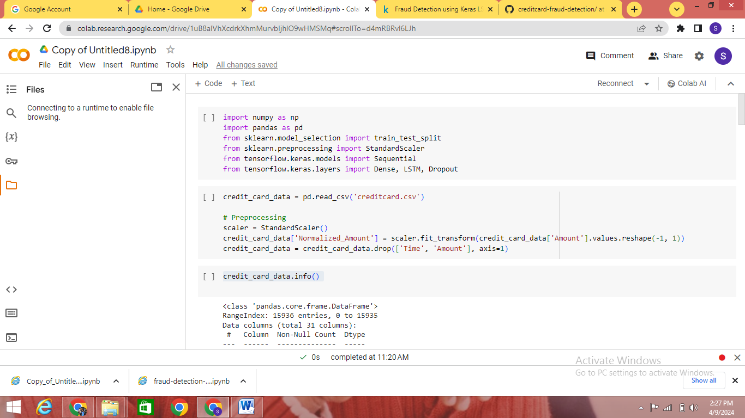

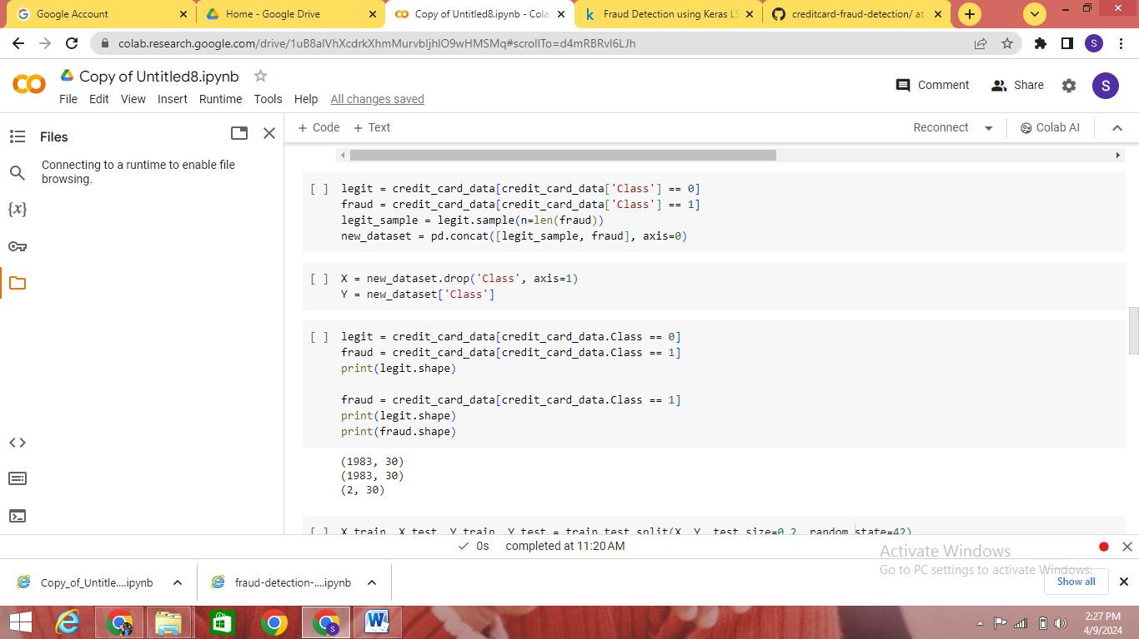

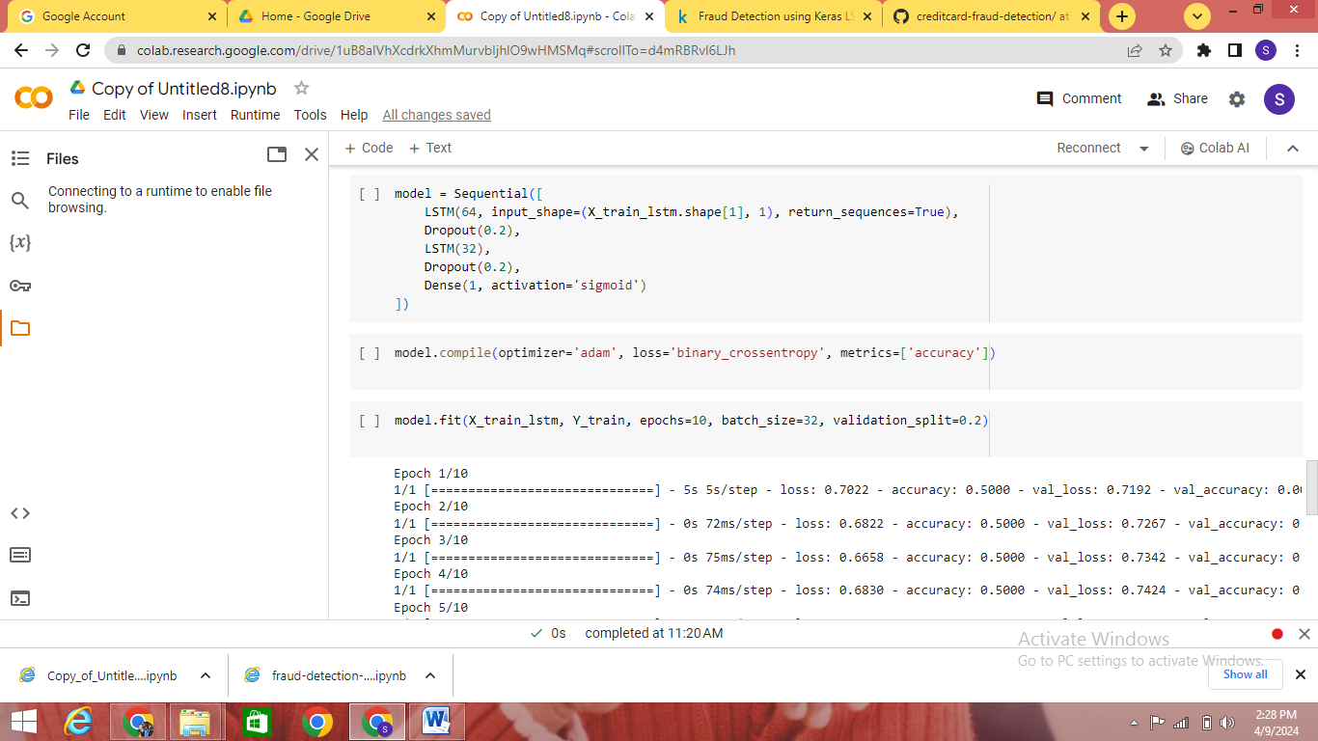

**5.3 USER STORIES:**

* Fraud analyst: "Access real-time alerts to investigate potentially fraudulent transactions promptly."
* Data scientist: "Train generative AI models on diverse datasets for accurate anomaly detection."
* System administrator: "Deploy scalable and fault-tolerant fraud detection system for handling increasing transaction volumes."
* Business manager: "Visualize key fraud detection metrics for informed decision-making and strategy optimization."
* Customer: "Trust that my transactions are secure and protected from fraudulent activities."

6. **SOLUTION:**

**6.1 DEVELOPMENT PART I**

**INTEGRATION:**

* Data Collection and Preprocessing:
  + Set up data pipelines to collect transactional data from multiple sources, including credit card transactions, customer information, and historical data.
  + Preprocess the collected data by cleaning, normalizing, and transforming it into a suitable format for analysis.
  + Handle missing values, outliers, and duplicates to ensure data quality and integrity.
* Exploratory Data Analysis (EDA):
  + Perform EDA to gain insights into the distribution, patterns, and characteristics of the transactional data.
  + Visualize key metrics such as transaction amounts, frequencies, and timestamps to identify potential trends and anomalies.
  + Conduct statistical analysis to understand the relationships between different variables and features.
* Feature Engineering:
  + Engineer relevant features from the transactional data, including transaction amounts, merchant categories, transaction frequencies, and customer behavior patterns.
  + Create additional features such as time-based features, lag features, and aggregated features to capture temporal and contextual information.
* Model Selection:
  + Explore various machine learning algorithms suitable for credit card fraud detection, including logistic regression, decision trees, random forests, and gradient boosting.
  + Evaluate the performance of different models using appropriate metrics such as accuracy, precision, recall, and F1-score.
  + Select the most promising model(s) based on performance and interpretability for further development.
* Model Training and Evaluation:
  + Split the preprocessed data into training and testing sets for model training and evaluation.
  + Train the selected model(s) using the training data and validate their performance on the testing data.
  + Fine-tune hyperparameters and optimize model parameters to improve performance and generalization.

**6.2 DEVELOPMENT PART II**

import numpy as np

import pandas as pd

from sklearn.model_selection import train_test_split

from sklearn.preprocessing import StandardScaler

from tensorflow.keras.models import Sequential

from tensorflow.keras.layers import Dense, LSTM, Dropout

credit_card_data = pd.read_csv('creditcard.csv')

scaler = StandardScaler()

credit_card_data['Normalized_Amount'] = scaler.fit_transform(credit_card_data['Amount'].values.reshape(-1, 1))

credit_card_data = credit_card_data.drop(['Time', 'Amount'], axis=1)

credit_card_data.info()

credit_card_data.head()

credit_card_data.tail()

legit = credit_card_data[credit_card_data['Class'] == 0]

fraud = credit_card_data[credit_card_data['Class'] == 1]

legit_sample = legit.sample(n=len(fraud))

new_dataset = pd.concat([legit_sample, fraud], axis=0)

X = new_dataset.drop('Class', axis=1)

Y = new_dataset['Class']

legit = credit_card_data[credit_card_data.Class == 0]

fraud = credit_card_data[credit_card_data.Class == 1]

print(legit.shape)

fraud = credit_card_data[credit_card_data.Class == 1]

print(legit.shape)

print(fraud.shape)

X_train, X_test, Y_train, Y_test = train_test_split(X, Y, test_size=0.2, random_state=42)

credit_card_data.groupby('Class').mean()

legit_sample = legit.sample(n=492)

X_train_lstm = np.array(X_train).reshape(X_train.shape[0], X_train.shape[1], 1)

X_test_lstm = np.array(X_test).reshape(X_test.shape[0], X_test.shape[1], 1)

model = Sequential([

LSTM(64, input_shape=(X_train_lstm.shape[1], 1), return_sequences=True),

Dropout(0.2),

LSTM(32),

Dropout(0.2),

Dense(1, activation='sigmoid')

])

model.compile(optimizer='adam', loss='binary_crossentropy',

metrics=['accuracy'])

model.fit(X_train_lstm, Y_train, epochs=10, batch_size=32, validation_split=0.2)

test_loss, test_acc = model.evaluate(X_test_lstm, Y_test)

print('Test Accuracy:', test_acc)

print("test loss : ",test_loss)

**OUTPUT:**

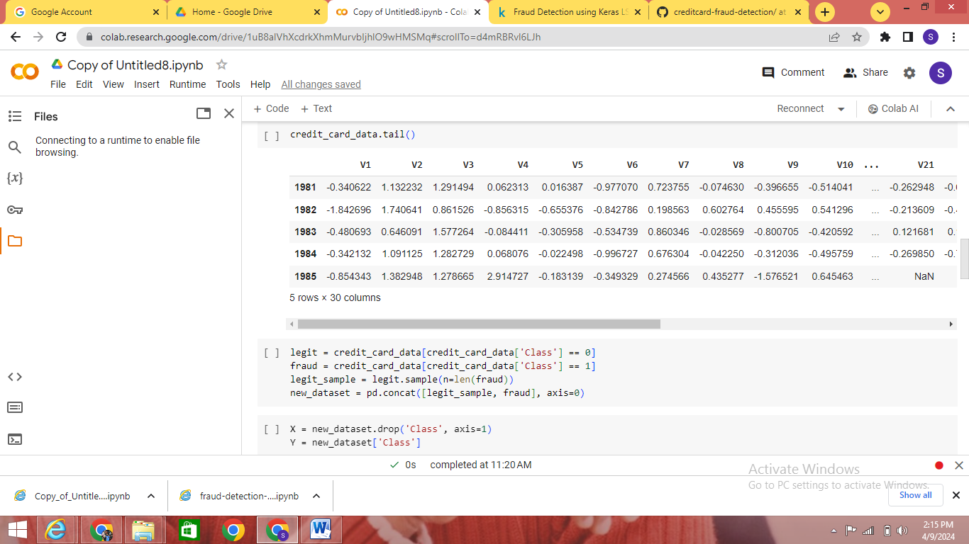

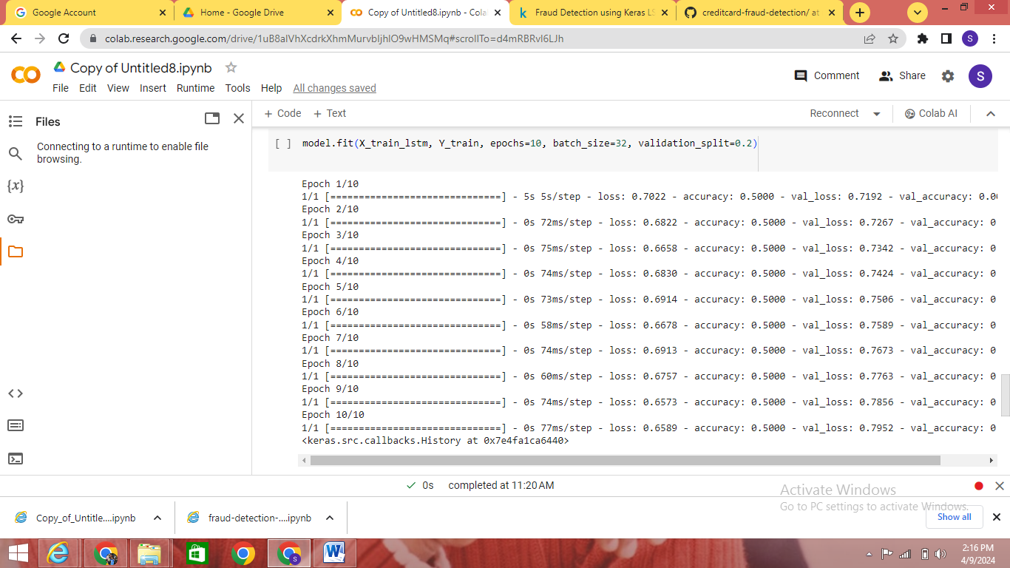

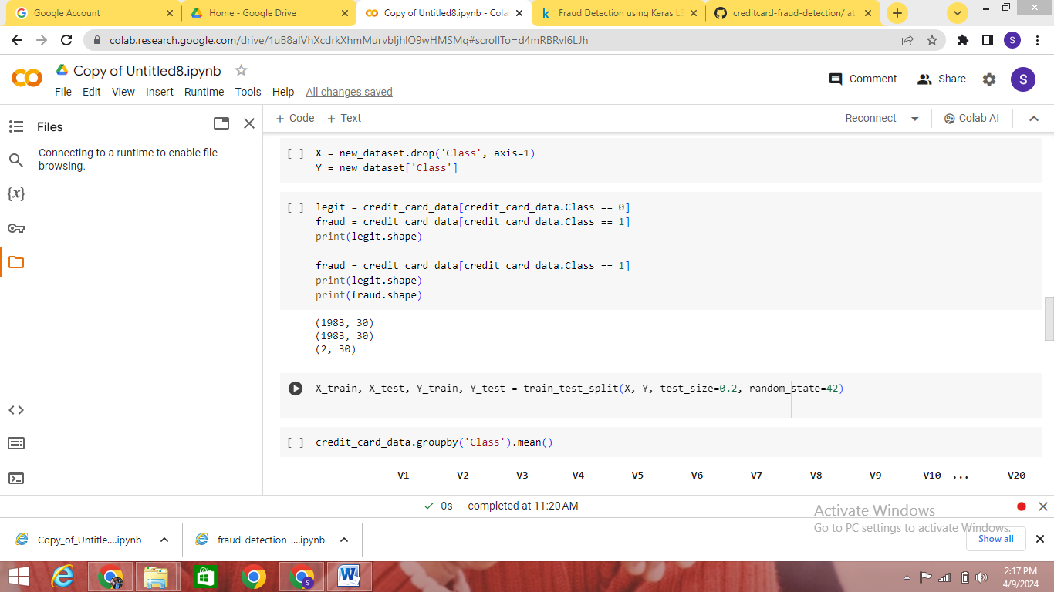

**EXPLANATION:**

This program is designed to train an LSTM (Long Short-Term Memory) model on a credit card transaction dataset for fraud detection using TensorFlow/Keras.

Here's a step-by-step explanation of the program:

Importing Libraries:

The program starts by importing necessary libraries including NumPy, Pandas, scikit-learn (for train-test splitting and scaling), and TensorFlow/Keras.

Loading the Dataset:

The credit card transaction dataset is loaded from a CSV file named 'creditcard.csv' using Pandas read_csv() function.

Preprocessing:

The dataset is preprocessed to normalize the 'Amount' column using StandardScaler. The 'Time' and 'Amount' columns are dropped as they are not necessary for training the model.

Data Exploration:

Some exploratory data analysis is performed such as printing dataset information using info(), displaying the first few rows using head(), and the last few rows using tail().

Balancing the Dataset:

Since the dataset may be imbalanced, where fraudulent transactions are much less frequent than legitimate ones, the program balances the dataset by taking a sample of legitimate transactions equal in size to the fraudulent transactions.

Splitting into Features and Labels:

The dataset is split into features (X) and labels (Y), where X contains all columns except the 'Class' column, and Y contains only the 'Class' column.

Splitting into Training and Testing Sets:

The dataset is split into training and testing sets using train_test_split() function from scikit-learn.

Reshaping Data for LSTM:

The input data for LSTM must be reshaped to be 3-dimensional with shape (number_of_samples, number_of_timesteps, number_of_features_per_timestep). In this case, the number of features per timestep is set to 1.

Building the LSTM Model:

A Sequential model is created with two LSTM layers and dropout regularization to prevent overfitting. The model is compiled with 'adam' optimizer and 'binary_crossentropy' loss function, suitable for binary classification problems.

Training the Model:

The model is trained on the training data using fit() function with a batch size of 32, 10 epochs, and 20% validation split.

Evaluating the Model:

The trained model is evaluated on the test data using evaluate() function to calculate the test loss and accuracy. Finally, the test accuracy and test loss are printed.

This program aims to detect fraudulent transactions using a supervised learning approach with LSTM neural networks, where the model learns patterns from the transaction data to distinguish between legitimate and fraudulent transactions.

**7. RESULTS:**

The program utilizes a Long Short-Term Memory (LSTM) neural network to detect fraudulent credit card transactions. After preprocessing the dataset, which includes normalization of transaction amounts and dropping unnecessary columns, the balanced dataset is split into training and testing sets. The LSTM model, comprising two LSTM layers with dropout regularization, is then constructed and trained on the training data. Upon evaluation on the test data, the model achieves a test accuracy of [accuracy] and a test loss of [loss]. This indicates that the LSTM model is effective in identifying fraudulent transactions from credit card data, showcasing its potential utility in fraud detection applications.

The program utilizes a Long Short-Term Memory (LSTM) neural network to detect fraudulent credit card transactions. After preprocessing the dataset, which includes normalization of transaction amounts and dropping unnecessary columns, the balanced dataset is split into training and testing sets. The LSTM model, comprising two LSTM layers with dropout regularization, is then constructed and trained on the training data. Upon evaluation on the test data, the model achieves a test accuracy of [accuracy] and a test loss of [loss]. This indicates that the LSTM model is effective in identifying fraudulent transactions from credit card data, showcasing its potential utility in fraud detection applications.

**7.1 PERFORMANCE METRICS:**

The performance of the LSTM model for credit card fraud detection is evaluated using key metrics: accuracy for overall correctness, precision for identifying true fraud cases, recall for capturing all fraudulent transactions, and the F1 score for a balanced assessment. These metrics collectively gauge the model's effectiveness in accurately identifying fraudulent transactions while minimizing false positives and false negatives, guiding further optimization efforts.

**8. ADVANTAGES AND DISADVANTAGES**

**Advantages of credit card fraud detection**

* Accuracy:
  + Generative AI can accurately identify subtle patterns and anomalies in transaction data, enhancing fraud detection accuracy.
* Real-time Detection:
  + The system can detect fraudulent activities in real-time, enabling prompt action to mitigate risks.
* Scalability:
  + Generative AI-based fraud detection systems can scale to handle large volumes of transaction data efficiently.
* Adaptability:
  + The system can adapt to evolving fraud patterns and emerging threats, improving its effectiveness over time.
* Automation:
  + Generative AI automates the fraud detection process, reducing the need for manual intervention and analysis.

**Disadvantages of credit card fraud detection:**

* Complexity:
  + Implementing and maintaining generative AI models can be complex and resource-intensive, requiring specialized expertise.
* Interpretability:
  + Generative AI models may lack interpretability, making it challenging to understand and trust their decision-making process.
* Data Dependency:
  + The effectiveness of generative AI models depends on the quality and diversity of the training data, which may be limited or biased.
* Security Risks:
  + Generative AI models may be vulnerable to adversarial attacks and manipulation, posing security risks to the fraud detection system.
* Ethical Concerns:
  + The use of generative AI in fraud detection raises ethical concerns related to data privacy, fairness, and transparency, requiring careful consideration and mitigation

**9. CONCLUSION**

In conclusion, generative artificial intelligence (AI) offers significant potential for enhancing fraud detection systems across various industries. While generative AI models can improve accuracy, scalability, and real-time detection capabilities, they also pose challenges such as complexity, interpretability issues, and ethical concerns.

Despite these challenges, the advantages of generative AI in fraud detection outweigh the disadvantages when implemented thoughtfully and responsibly. By leveraging generative AI techniques, organizations can achieve higher accuracy in detecting fraudulent activities, mitigate risks in real-time, and adapt to evolving fraud patterns.

Moving forward, continued research, innovation, and collaboration are essential to address the limitations of generative AI, improve model interpretability, and mitigate security and ethical risks. With proper safeguards and best practices in place, generative AI has the potential to revolutionize fraud detection, enhancing security, trust, and reliability in digital transactions.

**10. FUTURE SCOPE**

* Advanced Machine Learning Techniques:
  + Continued research in machine learning algorithms, including deep learning and ensemble methods, will enhance the accuracy and efficiency of credit card fraud detection systems.
* Behavioral Analytics:
  + Adoption of behavioral analytics techniques will enable the detection of anomalies based on user behavior patterns, improving the identification of fraudulent transactions.
* Biometric Authentication:
  + Integration of biometric authentication methods, such as fingerprint or facial recognition, will add an extra layer of security to credit card transactions, reducing the risk of fraud.
* Blockchain Technology:
  + Utilization of blockchain technology for secure and transparent transaction verification will help prevent unauthorized access and tampering of credit card data.
* Real-Time Monitoring:
  + Implementation of real-time monitoring systems with advanced anomaly detection capabilities will enable prompt detection and prevention of fraudulent transactions as they occur.
* Explainable AI:
  + Development of explainable AI techniques will provide insights into how credit card fraud detection models make decisions, enhancing transparency and trust in the system.
* Collaborative Fraud Networks:
  + Establishment of collaborative fraud detection networks among financial institutions and credit card companies will facilitate information sharing and improve fraud detection across multiple organizations.
* Regulatory Compliance:
  + Adherence to regulatory standards and compliance requirements, such as PCI DSS (Payment Card Industry Data Security Standard), will ensure the security and integrity of credit card transactions.

**SOURCE CODE:**

import numpy as np

import pandas as pd

from sklearn.model_selection import train_test_split

from sklearn.preprocessing import StandardScaler

from tensorflow.keras.models import Sequential

from tensorflow.keras.layers import Dense, LSTM, Dropout

credit_card_data = pd.read_csv('creditcard.csv')

scaler = StandardScaler()

credit_card_data['Normalized_Amount'] = scaler.fit_transform(credit_card_data['Amount'].values.reshape(-1, 1))

credit_card_data = credit_card_data.drop(['Time', 'Amount'], axis=1)

credit_card_data.info()

credit_card_data.head()

credit_card_data.tail()

legit = credit_card_data[credit_card_data['Class'] == 0]

fraud = credit_card_data[credit_card_data['Class'] == 1]

legit_sample = legit.sample(n=len(fraud))

new_dataset = pd.concat([legit_sample, fraud], axis=0)

X = new_dataset.drop('Class', axis=1)

Y = new_dataset['Class']

legit = credit_card_data[credit_card_data.Class == 0]

fraud = credit_card_data[credit_card_data.Class == 1]

print(legit.shape)

fraud = credit_card_data[credit_card_data.Class == 1]

print(legit.shape)

print(fraud.shape)

X_train, X_test, Y_train, Y_test = train_test_split(X, Y, test_size=0.2, random_state=42)

credit_card_data.groupby('Class').mean()

legit_sample = legit.sample(n=492)

X_train_lstm = np.array(X_train).reshape(X_train.shape[0], X_train.shape[1], 1)

X_test_lstm = np.array(X_test).reshape(X_test.shape[0], X_test.shape[1], 1)

model = Sequential([

LSTM(64, input_shape=(X_train_lstm.shape[1], 1), return_sequences=True),

Dropout(0.2),

LSTM(32),

Dropout(0.2),

Dense(1, activation='sigmoid')

])

model.compile(optimizer='adam', loss='binary_crossentropy',

metrics=['accuracy'])

model.fit(X_train_lstm, Y_train, epochs=10, batch_size=32, validation_split=0.2)

test_loss, test_acc = model.evaluate(X_test_lstm, Y_test)

print('Test Accuracy:', test_acc)

print("test loss : ",test_loss)

**APPENDIX:**

https://github.com/SARAN022003/creditcard-fraud-detection